1 : Three differences between Ethernet cables and fiber-optic cables

Feature | Ethernet Cable | Fiber-Optic Cable
Signal type | Transmits data using electrical signals. | Transmits data using light signals.
Speed and distance | Supports high speeds, but performance depends on cable category and distance. Typical twisted-pair Ethernet channels support up to 100 m. | Supports very high speeds over longer distances, depending on fiber type and equipment.
Cost and installation | Usually cheaper and easier to install for short connections. | Usually costs more to install and requires specialized tools and equipment.
Real-world example | Connecting a home Wi-Fi router to a desktop PC. | Connecting network switches between buildings on a college campus.

2 : Straight-through Ethernet cable diagram (T568B standard)

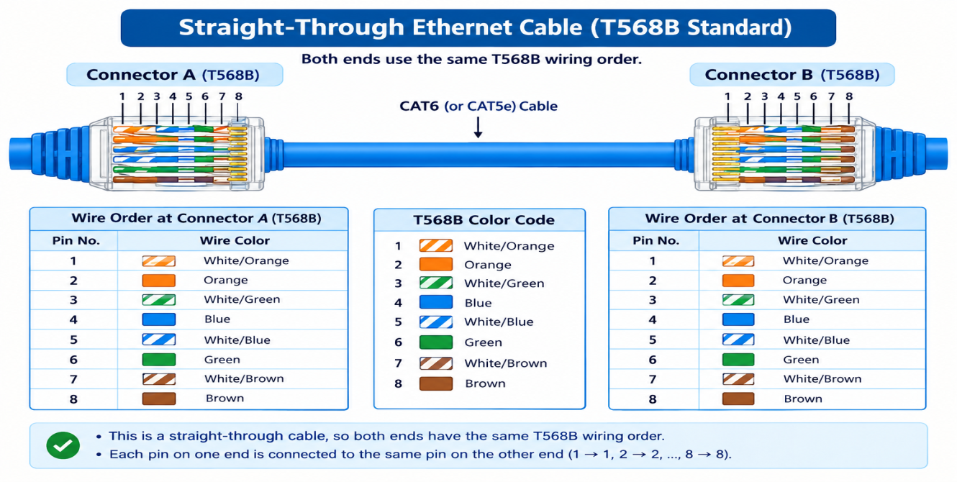
3. Step-by-step guide to attach an RJ45 connector to a CAT6 cable

1. Cut the cable: Cut the CAT6 cable to the required length using a cable cutter.
2. Strip the cable: Remove about 2–3 cm of the outer jacket carefully without damaging the inner wires.
3. Arrange the wires: Untwist and arrange the eight wires in T568B order: White/Orange, Orange, White/Green, Blue, White/Blue, Green, White/Brown, Brown.
4. Trim the wires: Cut all eight wires evenly so they fit properly inside the RJ45 connector.
5. Insert the wires: Insert the wires into the RJ45 connector in the correct order. Make sure all wires reach the end.
6. Crimp the connector: Place the RJ45 connector into the crimping tool and squeeze the handles firmly.
7. Test the cable: Use a LAN cable tester to check that all eight wires are connected correctly.
8. Repeat at the other end: Attach another RJ45 connector using the same T568B wiring order to make a straight-through cable.

4 : Gaming café with 10 PCs: cable and tool selection
I would choose CAT6 Ethernet cables and an RJ45 crimping tool for a gaming café with 10 PCs. CAT6 provides fast, stable connections and low latency for LAN gaming, while being affordable for short distances inside the café. The RJ45 crimper is used to attach compatible connectors to the cable ends. Fiber-optic cable and a fiber cleaver would be unnecessary for these short PC connections, although fiber could be useful for a longer backbone link.

